

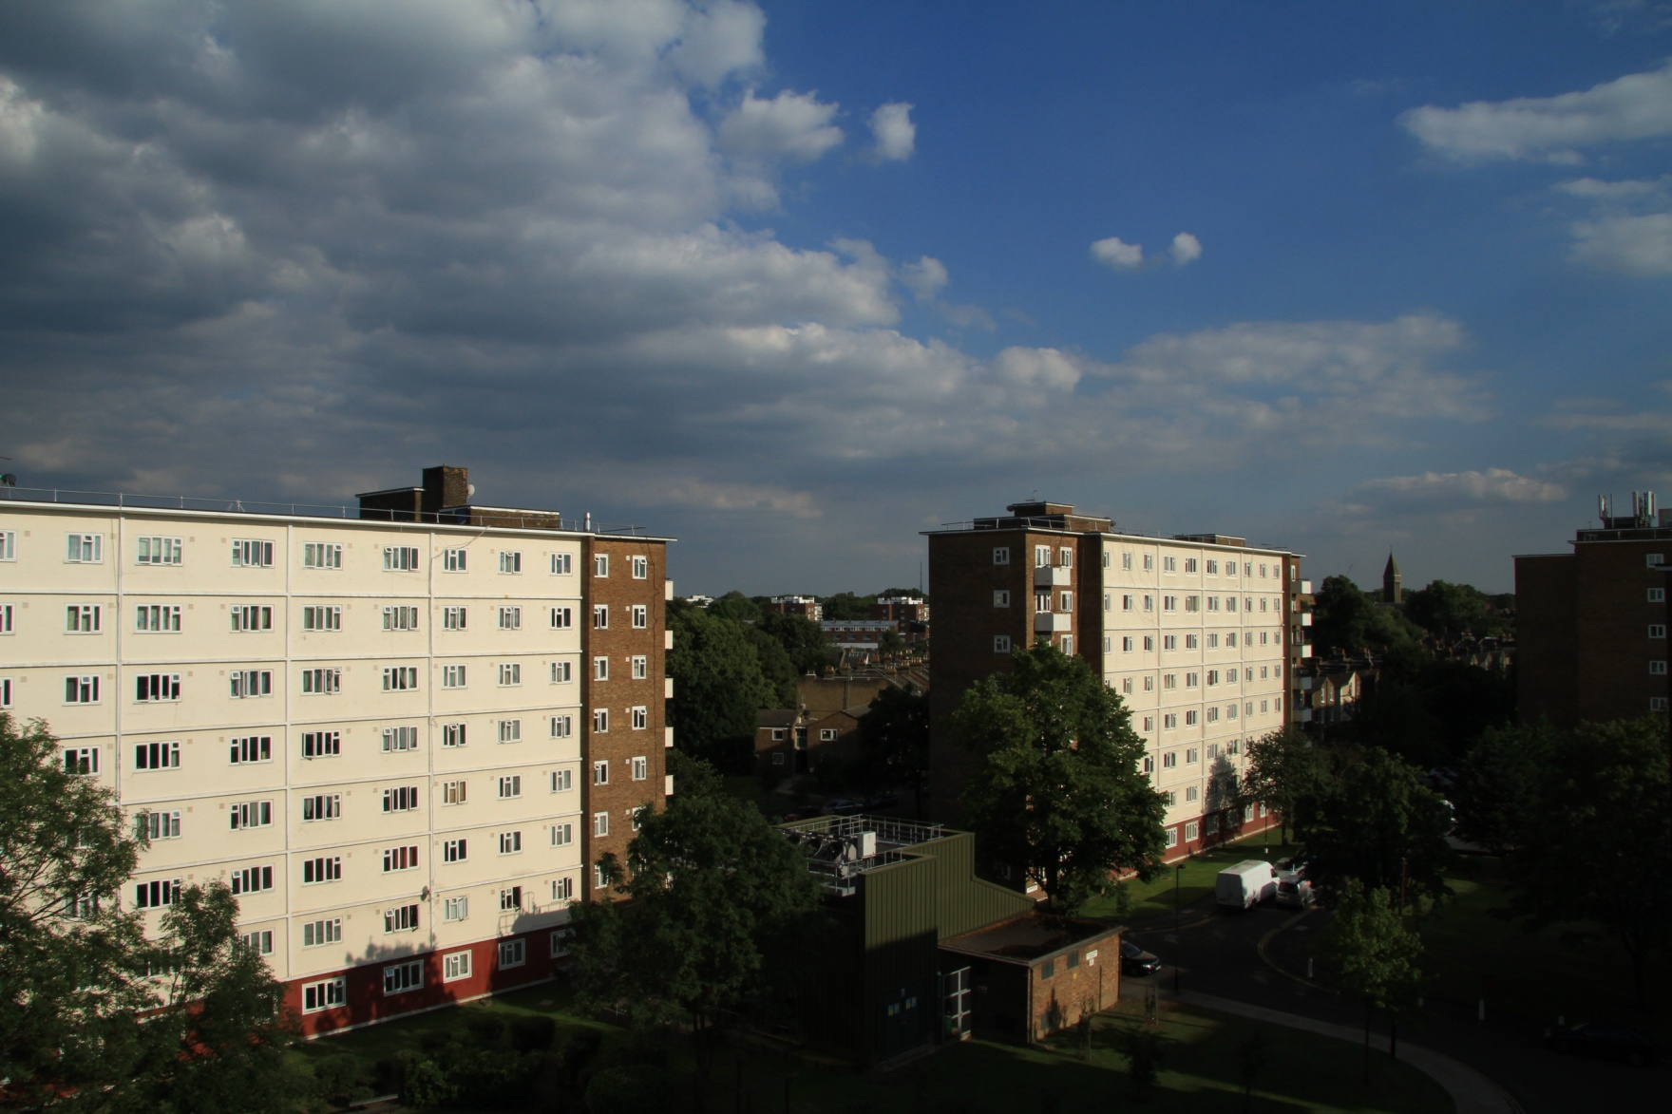

**ROUPELL PARK**

**RESIDENT MANAGEMENT CO-OPERATIVE**

**Business Plan 2014 - 2017**

|  |  |  |  |
| --- | --- | --- | --- |
| **Revision Number** | **Reason for Revision** | **Date** | **Adopted by Board** |
| Version 1 (draft) |  | 23 July 2014 |  |
| Version 2 | Reflect Estate Director and chair changes | 28 July 2014 |  |
| Version 3 | Estate Director and board changes and photos added | 26 August 14 |  |

**Registered Office: Office Opening hours:**

Community Office

Brockham Drive Monday, Thursday, Friday 8.30am to 5pm

Roupell Park Estate Tuesday 9am to 5pm

London Wednesday 9am to 1pm

SW2 3RY Friday 9am to 4pm

Telephone: [020 7926 0219](javascript:void(0)) Fax: 02079260218

Email: RoupellPark@lambeth.gov.uk

*Roupell Park Residents Management Co-operative Ltd is a not for profit Industrial and Provident Society registered in England and Wales Registration no.*28197R

Contents: Page no.

1. **Introduction 5**
2. **Who we are** **7**

About our community

Our team

Our services

Our Performance and achievements

Key issues for the community

The operational environment we work in

1. **What we aim to achieve** **26**

Our vision, mission and values

Our core values

Our strategic objectives and key action points

Monitor our performance

Working with our residents

1. **Managing our finances 32**

TMO Allowances and Income

Expenditure

Designated Reserves

Surplus Fund

Just in Case – Sensitivity analysis

Closing the gap

Three year financial forecast Table 1

Surplus spend proposals Table 2

Just in case - Sensitivity analysis Table 3

1. **Managing risk** **38**

Risk assessment – the top 12 risks to RPRMC’s future

1. **Appendices 42**

Appendix A – Jargon Buster - *RPRMC tries to use every day language to describe what we do. However, should you find a term that you do not understand, please turn to our Jargon Buster*

Appendix B – TMO responsibilities under the Management Agreement

Appendix C – Strengths, weaknesses, opportunities and threats analysis

Appendix 4 – TMO Action Plan

1. **Introduction**

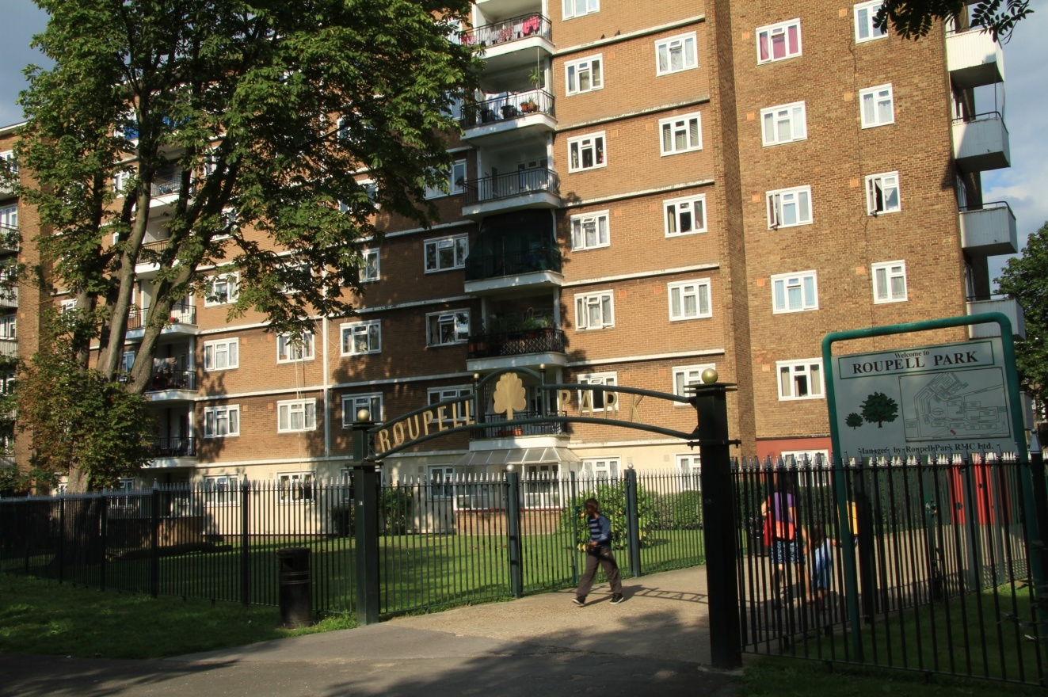Roupell Park Residents Management Cooperative (RPRMC) manages 573homes (405 tenanted, 165 leasehold, 3 freehold). There are 15 blocks of flats (2 to 7 storey) centred around well maintained estate greens, a ball park area and childrens play areas. Roupell Park estate is situated at the top of Brixton Hill in the London borough of Lambeth with excellent transport links to both Brixton and Streatham and onward to Central London. Its location also means that it has close ties to Tulse Hill. It does not therefore sit comfortably into any single neighbourhood community but rather has both the advantages and disadvantages of having links to several.

RPRMC wasone of the first of some 15Tenant Management Organisations (TMO)in the borough and was set up under the Right to Manage Regulations in 1996.

**Roupell Park**

This Business Plan was put together following consultation with local estate residents. It covers a three year period until March 2017 and sets out our Vision for our estate and community. It includes our plans for the future including how we will improve our estate and amenities and sets out how we will deliver on our key objectives.

It describes how RPRMC will work withlocal residents and our partners to improve not just homes and our estate but also the quality of life for our community. As a community led organisation, this is very important to us and providesa central focus for all we do.

We hope you find our Business Plan informative. If you have any comments or questions, please callour officeon [020 7926 0219](javascript:void(0))or call into the office at Brockham Drive, Monday to Friday between 9am and 5pm.

If you would like a copy of this Business Plan in large print or another format, please let the office know or e-mail us onRoupellPark@lambeth.gov.uk

**2. Who we are**

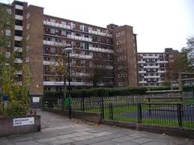RPRMC was the brainchild of a small number of residents who wanted to improve their homes and the local environment and to develop a real sense of community. The TMO officially started life in1995 as a registered Industrial and Provident Society. We are a not for profit benefit of the community society which means that any ‘profit’ we make (we call it surplus) must be used for the benefit of our community. We signed a management agreement with Lambeth Council in 1996 to enable the TMO to provide a range of housing services to the Roupell Park Estate

The TMO is a member owned organisation and has over 264registered members representing 47%of estate households. Each member holds a share to the value of £1 which entitles them to participate in the decision making processes of the TMO and to stand for election to the board. But we deliver services to all of the residents of the estate regardless of whether they are members.

Our TMO is managed by a management board which consists of residents who are elected at the Annual General Meeting and/or co-opted during the year. Councillors and council officers are also invited to attend our board meetings. All resident board members are volunteers who do not receive payment for their work on behalf of RPRMC.

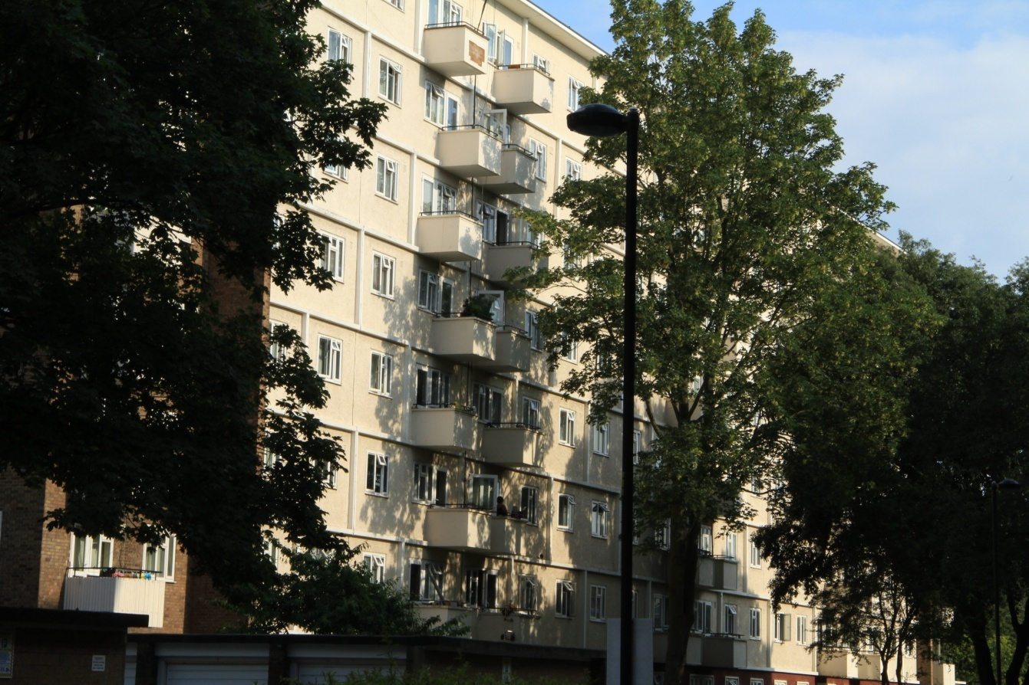**Meet the Management Board**

The membership of our board is follows:

Mary Simpson – Chair

Alex Ekumah - Secretary

Oni Idigu - Treasurer

Sara Kulay

Janet Grant

Molly Sinclair

Marcia Jones

Alieu Corneh,

Sandra Yamoah,

Munya Mtetwa

Amy Roberts

Our chief officer is the Estate Director Simon Oelman who manages our staff team (see page 12).

**About Our Community**

With the largest geographic area of any inner London borough, more than a third of a million people live in Lambeth – 303,086. This makes Lambeth the third largest London borough behind Newham and Wandsworth. Largely residential, Lambeth is one of the most densely populated places in the country, with 113 people living in each hectare of land, the fifth highest for population density in the country. It has a high turnover of population - about 10% of the population leave each year and are replaced by around 10% new arrivals; but this high level of population change masks the fact that, in the main, many Lambeth residents have lived in the borough for a long time – the April 2013 Council residents’ survey indicates that 66% of the population has been resident for over five years, and 52% over ten years.

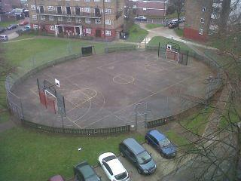

Like most council estates in Lambeth, Roupell Park estate has a diverse tenure mix with 29% leaseholders. 30% of these are non residential i.e. they generally sublet their properties. The Estate sits in an area of relative affluence with neighbouring houses valued in excess of £0.6m and flats on the estate selling for in excess of £250,000 and one of the houses on Brockham Drive having been put on the market for £0.5m. Private rents are high reflecting the proximity to the centre of London.

Benefit levels on the estate are relatively low in relation to other social housing schemes with only 56% of tenants currently claiming housing benefit. This compares with a Lambeth average of 63.9%. Whilst it is not possible at this stage to identify wider deprivation indices to the level of the estate, the census data shows that the super output area in which most of the estate sits is in the top 25% deprived areas in the country overall and top 16% level of unemployment. However this contrasts with eight areas within the borough which are in the top 10% highest areas of multiple deprivation.

**Diversity[1]**

Lambeth is an extremely ethnically diverse boroughwhich has the highest proportions in the country for residents who arePortuguese born, South American, mixed race white and black African, from multiple mixed ethnic backgrounds and from non-Caribbean and non-African black backgrounds

Roupell Park Estate also has a very diverse community with around 62% of tenants being from black and minority ethnic communities. 54% of the estate consider themselves to be black (45% for the Borough as a whole), 36% white (34%), with no other group on the estate amounting to more than 2% of the population.Of those who consider themselves to be black, 54% are Black Caribbean and 39% Black African. Of those considering themselves to be white 61% are white British with the largest other white group being Portuguese.

Of those estate tenants[2]identifying themselves as having faith 74% are Christian. The next largest group 13% identify themselves as having no faith and 9% are Muslim. These figures are roughly in line with Lambeth as a whole.17.5% of tenants consider themselves to have a disability or other vulnerability. This compares with only 8% for Lambeth as a whole.

Lambeth generally has a young age profile, 2011 Census data shows that older people make up a smaller proportion of the population with 6.7% of people aged 65-84 years compared to 7.6% for inner London.In Roupell Park, 19% of tenants are over retirement age, significantly higher than the Lambeth and London average. 65% of main tenants are female. 39% of tenants are between 25 and 44 and the same proportion between 45 and 64. This is lower than Lambeth as a whole. It should however be noted that these figures only relate to tenants and that no information is held on leaseholders or private tenants.

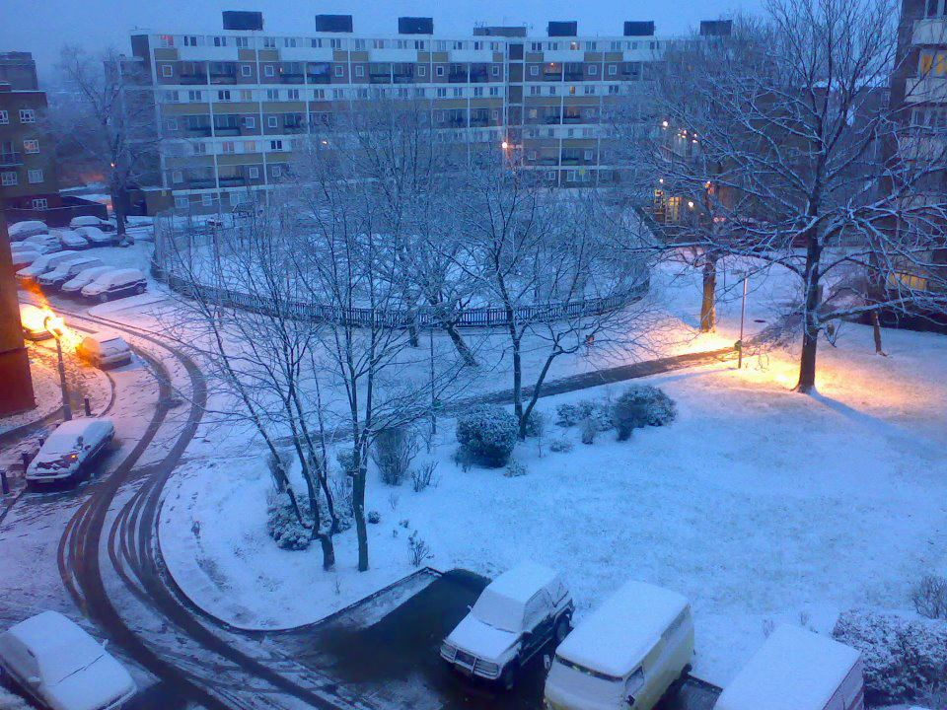Like the rest of Lambeth Roupell Park is therefore a very diverse community although it has its own unique character and mix of ages and ethnic and racial groups. This gives the estate its own character and helps shape its relationship with the area in which it is set.

Our Team

We currently employ fifteen members of staff. Our organisational structure is as follows:

We also employ the services of contractors to provide the following services:

* Grounds maintenance;
* Parking enforcement;
* Gas servicing and repairs;
* Communal heating repairs;
* Repairs that are not provided by our in house team such as specialist work e.g. electrical;
* HR support and advice.

Our services

We have entered into a management agreement with Lambeth Council which sets out the services that RPRMC provides. The agreement, which forms a legally binding contract, was reviewed and updated in 2014 using the December 2013 edition of the Right to Manage Modular Management Agreement and schedules.

The Council has delegated its housing management to Lambeth Living, its Arms Length Management Organisation. So Lambeth Living deliver all of the services that are the council’s responsibility under the management agreement on behalf of the Council. Our responsibilities under the terms of the management agreement are as follows:

**Our Organisation**

* Ensuring effective governance of the TMO including increasing membership,board membership and sustainability, accountability, and an effective split between governing and operational activities;
* Consulting and involving residents through meetings, surveys, newsletters and events to ensure that the services we provide meet their needs;
* Managing the TMO’s finances effectively and reporting to our membership, the Financial Conduct Authority, and Lambeth Council in accordance with the Management Agreement;
* Providing an estate based office;
* Maintaining an efficient, effective, motivated staff team;
* Effective management of contractors employed by RPRMC and ongoing assessment for value for money;
* Monitoring the effectiveness of contractors employed by Lambeth Living and representing the needs of Roupell Park residents to the Council;
* Providing monitoring reports to the Council as required*;*
* Ensuring regular satisfaction surveys are carried out and results analysed, reported back to residents and acted upon;
* Producing an Annual Report to all residents on our performance across all areas;
* Working with other agencies and community groups to identify and address the needs of our community.

**Our Services**

* Responsive repairs and maintenance up to £5,000 per repair through our in house team supported by contractors;
* Communal heating repairs;
* Gas servicing and repairs;
* Out of hours emergency service;
* Pest control;
* Maintenance of CCTV systems;
* Maintenance of estate lighting;
* Maintenance of door entry systems
* Older people discretionary decorations;
* Providing a cleaning serviceto the communal areas of the blocks and the estate;
* Maintaining the gardens and grounds;
* Graffiti removal;
* Bulk refuse removal service;
* Parking enforcement;
* Day to day inspections of the play areas;
* Managing and preparing void properties for re letting up to £5,000 (not including decent homes works);
* Identifying the need for major works and lobbying the Council to programme these works;
* Delivering major works funded from any identified TMO specific budget;
* Dealing with tenancy management issues including investigation into complaints of anti-social behaviour, unlawful occupancies, breach of tenancy or lease agreement, residents disputes, and taking legal action when appropriate;
* Dealing with succession claims;
* Processing mutual exchanges;
* Giving consents to residents for a range of issues from improvements to keeping pets;
* Arranging and processing on estate transfers for downsizing tenants;
* Monitoring tenants’ rent payments (which are made directly into the council’s bank account) on the council’s computer system and taking action when appropriate;
* Managing tenants’ rent arrears and taking legal action if appropriate;
* Assisting residents with housing benefit claims;
* Managing leaseholder service charge arrears and taking legal action if appropriate;
* Gaining entry for the eviction of tenantswhere a court order has been obtained;
* Accompanying bidders on assisted viewings of vacant properties;
* Providing an initial meeting with the Estate Manager for all new tenants regarding advising on tenancy rights and responsibilities and TMO membership and participation and sign up of the tenancy agreements
* Settling in visits for new tenants;
* Tenancy audits;

The Council retains responsibility for:

* Maintenance of lifts, dry risers and lightning conductors;
* Asbestos removal;
* Setting rent levels;
* Leaseholder’s service charge billing and collection;
* Maintaining the structure of the buildings;
* All repairs over £5,000;
* Programming, commissioning and undertaking major works including Decent Homes works in consultation with the TMO;
* Refuse collection;
* Tree maintenance.

Our Performance and Achievements

We closely monitor the services provided by our staffteam and our contractors through monthly performance reports to the board.

We report to Lambeth Council on a set of pre determined performance indicators on a quarterly basis. These include repairs, vacant properties, complaints and settling in visits. The table below sets out our cumulative performance over the 2013/14 financial year. The ranking indicates our position amongst the 11 TMOs in the borough.

|  |  |  |  |  |
| --- | --- | --- | --- | --- |
| **Performance Indicator** | **Performance**  **2012/2013** | **Target 2014** | **Performance**  **March 2014** | **Ranking** |
| Rent Collection Rate In-year | 100.68% | 99% | 100.2% | 2 |
| Service Charge Collection | 104.71% | 98% | 103.1% | 4 |
| All Repairs Completed on Time | 97.4% | 97% | 95.58% | 9 |
| Tenants Satisfied with Repairs | 80.3% | 95% | 100% | 1 |
| Gas servicing carried out within 12 months of the previous service | 100% | 100% | 100% | 1 |
| Average time to relet Empty Homes (YTD) | 17.7 Days | 30 Days | 24.5 Days | 7 |

**Resident Satisfaction Survey**

The TMO carried out a resident satisfaction survey in March 2013. 100% of households were surveyed and a 26% response rate (30% for tenants, 16% for leaseholders) was achieved. The results were as follows:

Overview of satisfaction levels

* **91%** of residents (91% tenants) were satisfied with Roupell Park as a place to live
* **91%** of residents (90% tenants) would recommend Roupell Park to friends or relatives as a place to live
* **78%** of residents (77%) tenants knew Roupell Park was an RMO.
* **84%** of respondents were satisfied overall with the quality of the repairs service
* **89%** of all respondents knew who their caretaker was
* **44%** of respondents who reported anti social behaviour were satisfied with the way that their complaints was handled
* **59%**of respondents who made a complaint were satisfied with the way complaints were handled

**Key issues of concern**

The TMO performs very well in a number of areas exceeding performance targets and surpassing the performance on a number of TMOs and Lambeth Living. These include rent and service charge collection, satisfaction with the repairs service, gas servicing, and reletting vacant properties. However both the performance statistics and the resident satisfaction survey raise some areas for concern.

**Reports of Anti Social Behaviour (ASB)**

Respondents to the satisfaction survey indicated that 28% of residents said they had experienced anti social behaviourduring the last year and only 44% were satisfied with the way their report was dealt with. These figures do not tally with the number of reports received by the TMO office which is much lower (4 formal complaints received). There is some work for us to do here in establishing why there is such a disparity i.e. are residents experiencing ASB and not reporting it to the TMO office, are all ASB reports being logged as such. Moreover, while ASB is a notoriously difficult management area to deal with and achieve a resolution, the 44% satisfaction level is not acceptable to the TMO board.

**Complaints**

It is healthy for an organisation to receive complaints provided they are dealt with promptly and to the satisfaction of the complainant. 18% of residents said they had made a complaint in the last year which again does not tally with the level of complaints logged at the TMO office. Some disparity is to be expected as residents sometimes consider that a report of a repair or service issues such as lighting for example is a complaint. However only 59% of residents were satisfied with the way their complaint was dealt with and this is not satisfactory. Again this is an area that the board intend to explore in more detail with the intention of identifying reasons for the disparity between the survey responses and the office experience and improving the satisfaction levels.

**Our Achievements**

RPRMC held our continuation ballot in 2012. This is a consultation exercise we are required to carry out every 5 years inviting all tenants and leaseholders to state whether they want the TMO to continue managing the estate in a secret ballot. 35% of eligible residents voted in the ballot. 94% (191) voted in favour of the TMO continuing to manage the estate and 6% (12) against. When asked their opinion of RPRMC’s management of the estate 78% said good to excellent, 15% fair and 7% poor. This has given RPRMC a strong mandate to continue for the next 5 years.

**These are just some of our key achievements over recent years:**

* We worked closely with the then TMO ALMO (called URH) toinstall new roofs and lifts
* We installed new playground facilities on all the play areas on the estate
* Weinstalled an internet café suite for use by residents
* 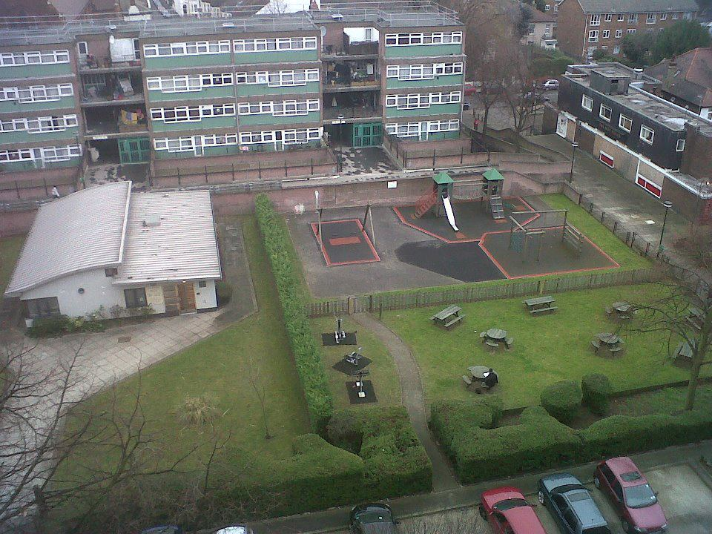We provided summer trips for residents and support for older people’s coffee mornings
* We gave financial support to Snowcamp so that a number of Roupell Park young people could attend training and obtain formal training qualifications and life skills
* We worked with the local nursery school on a gardening project that benefitted the children of residents attending the school
* We lobbied and worked with the Council to under-take road and pavement improvements to improve these areas on the estate
* We held residents days each year for the benefit of residents
* We introduced a recharge policy that allows all residents to have work done in their homes at an economic price
* Westarted an OAP decoration programme that gives over 70’s the opportunity of having two rooms decorated in their home every five years



* We have held a successful fun day on the estate in 2014 which over 300 people attended and 95% said they had a good time. We are working with residents to deliver the next event
* We are working with Lambeth Living to have the inside of our homes refurbished and to plan for a major repair programme to the outside of all of our blocks
* We have restructured the organisation to ensure we are able to deliver the best possible service

Funday football competition winners receiving their awards from Chuka Umunna MP

* We have let a new ground maintenance contract after extensive consultation and involvement with residents
* Our board members have attended meetings of the National Federation of TMO’s
* Roupell Park led the way in installing solar panels to reduce electricity bill on the estate and this currently amounts to roughly £700 a year. During the project 8 young people from the estate and local area completed a 15 week training and all 8 worked with professional installers as part of their paid work experience and one went on to securing a full time apprenticeship from a major building company



The Operational environment we work in

**Government policy**

Since the Coalition Government came into power in May 2010, there have been major changes which have impacted upon social housing and local government. Some of these changes have implications for TMOs not just as managing agents but also as community champions. These include:

* The introduction of self financing for local authorities and the abolition of the housing subsidy regime. Councils no longer rely on the annual subsidy settlement from central government but instead, in exchange for a settlement on capital debt, they can retain all of the income from rents and service charges. This has enabled councils to have a degree of certainty about their housing finances and to plan for the future. In some cases they have the freedom to borrow to invest in new build homes and/or in improving their existing housing stock.
* One large London TMO has entered a self financing arrangement with its council and some TMOs are considering this as an alternative to stock transfer;
* The introduction of affordable rents for new build homes (up to 80% of market rents);
* The requirement for all councils to publish a strategic tenancy policy setting out how they and their partner housing associations plan to meet the challenges ahead in terms of meeting housing need;
* The introduction of flexible tenancies ( time limited normally up to 5 years);
* Less government regulation and more local scrutiny of housing services with a key role for tenants;
* Welfare reforms including the (a) size criteria which links the amount of housing benefit to the number of bedrooms a household is entitled to occupy and (b) the introduction of Universal Credit which will replace most benefits including housing benefit and will be paid directly to the claimant. This will place a greater emphasis on tenants managing their own finances effectively and many landlords are concerned it will result in a rise in rent arrears;

**LambethCouncil**

Lambeth Council owns 29,000 homes approximately 8,000 of which are leasehold.The Council set up an Arms Length Management Organisation (ALMO) called Lambeth Living in 2008 to manage its housing portfolio. Lambeth Living has a management agreement with Lambeth Council in place until 2015. Lambeth Living provides the council retained housing functions to TMOs on the council’s behalf. Initially Lambeth Living was also responsible for monitoring and developing TMOs in the borough. However this function was taken ‘in-house’ by the council about 3 years ago with the creation of a TMO clienting team. Generally TMOs in the borough see this as a very positive step.

Lambeth Council has published its Tenancy Policy. It supports the use of secure lifetime tenancies in most instances, to contribute to building stable and cohesive communities and all Lambeth owned social housing will continue to be let on lifetime tenancies. However it has sanctioned the use of flexible tenancies by registered providers (housing associations) only in the case of larger family homes (properties with four or more bedrooms) and specially adapted properties, which are in very short supply in the borough, and for a proportion of bed-sit and one-bed properties.

Following a relatively recent stock transfer of three Lambeth TMOs to WATMOS Community Homes, there are now eleven TMOs in the borough and Roupell Park RMC is the second largest after Loughborough TMO. Between them, the TMOs manage 4512 properties.

|  |  |  |
| --- | --- | --- |
| **TMO** | **Borough Ward** | **Number of properties** |
| Angell Town RMO | Coldharbour | 444 |
| Blenheim Gardens RMO | Brixton Hill | 376 |
| CETRA TMC | Clapham Town | 380 |
| Cottinton Close TMC | Prince's | 247 |
| Cowley RMO | Vassall | 514 |
| Holland Rise TMO | Vassall | 103 |
| Loughborough EMB | Coldharbour | 1216 |
| PACCA TMO | Vassall | 285 |
| **Roupell Park RMC** | **Brixton Hill** | **569** |
| Waltham RMO | Ferndale | 238 |

The Council closely monitors the performance of all TMOs and Council Liaison Officers attend board meetings and AGMs. TMOs provide regular performance statistics against agreed key performance indicators and receive feedback from the Council in the form of TMO performance tables. The Council arranges regular TMO managers meetings, finance officer meetings and hosts the TMO Liaison committee to which all chairs and lead officers are invited.

The Council carried out a TMO allowance review in 2013/14 and TMOs have some degree of certainty over their allowances over the next two years. Annual changes are linked to changes in the management fee paid to Lambeth Living. The other variable in the allowances related to the leaseholder service charge element. If the TMO reduces the cost of leaseholder services such as communal repairs, cleaning, and ground maintenance, then the leaseholder service charges will reduce and as a result the leaseholder element of the allowances will be reduced. Similarly if these costs increase, the service charges and the leaseholder allowances will increase.

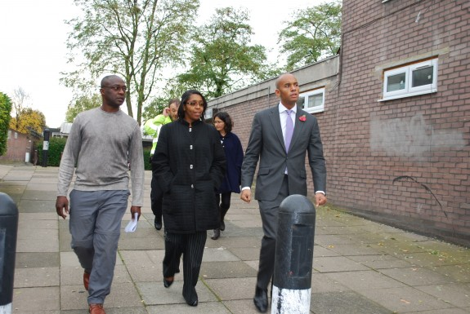

**Working with our partners**

We work closely with the Police, Social Services and other statutory agencies as the need arises. While we do have some liaison with the other ten TMOs in the borough, this could be improved to the benefit of all.

Our other key partners are Lambeth Council and specifically the TMO team and Lambeth Living who provide the retained services on the estate. We have worked hard to develop a positive working relationship with key officers in a range of departments. We welcome officer attendance at our meetings and attend joint TMO meetings arranged by the Council. We plan to try to develop a closer relationship with our ward councillors and as well as those councillors who hold a housing portfolio. Our local MP, Chuka Umunna visited the estate in July 2014 and we will continue to enlist his support for our plans.

Chuka Umunna MP visiting Roupell Park estate

**3. What we aim to achieve**

**Our Vision**

**Our Mission and Purpose**

To provide top quality housing services and community amenities that address the priorities of the community and that meetthe needs of residents.

**Our Core Values**

We have adopted the following **values** in order to reflect our commitment to providing the best possible services and empowering local people to be part of shaping these:

**Excellence -** Learning from our successes and our mistakes andstriving to be the best at what we do to deliver an exceptional service to our customers

**Integrity**- Being professional,open and honest in all our activities and delivering on our promises

**Fairness** - Treating our residents with respect and fairness showing consideration for their needs and celebrating their diversity

**Community -** Working together to build a cohesive community where volunteering is valued

**Partnership –** Working in collaboration with our community and partners to achieve shared goals

**Innovation –**Being ambitious for our community and trailblazing new approaches and new ideas that will deliver added value to our community

**Financial prudence**– Being sensible and careful when making judgements and decisions  and avoiding unnecessary risk to our finances

**Our Strategic Objectives**

We have developed three overarching strategic objectives to help us achieve our vision. Under each objective, we have set out some sub headings together with a number of specific action points which will help us to achieve our objectives.

**Strategic Objective 1: Delivering high quality homes and services**

|  |
| --- |
| **Create a clean, safe and welcoming environment with excellent facilities** |
| * Investigate the use of CCTV on estate hotspots to minimise crime, vandalism and deter unwanted activity * Work closely with Lambeth Living to ensure effective delivery of Decent Homes improvements and the capital programme * Investigate plans for enhancing estate shared spaces * Develop surplus spend plan in consultation with residents * Continue with programme of bringing unused garages back into service * Ensure communal TV system is fit for purpose |
| **Delivering excellent services that respond to the changing needs of residents** |
| * Develop and publicise Customer Care charter including service pledges to residents, training for staff * Set up residents mystery shopping with training for residents and reporting – consider incentives for residents taking part * Review IT provision and look athow our stand alone systems dovetail with the Lambeth systems we use; * Develop improvement plan with targets for estate cleaning and caretaking and investigate the potential for expanding weekend cleaning; * Review gardening provision on estate with the aim of involving residents and improving the quality of planting; * Annual/bi annual satisfaction survey with feedback newsletter * Improvement plan developed to address any areas where not meeting agreed standards |
| **Creating a safe, green environment and reducing our carbon footprint** |
| * Promote and facilitate increased levels of recycling * Increase biodiversity and wildlife through green space improvements * Engage community especially young people in green projects * Look at potential for community growing space and/or allotments * Develop office environmental policy to minimise waste and maximise recycling |

**Strategic Objective 2: Making our business stronger for the future**

|  |
| --- |
| **To make sure that our governance and staffing structure enables the successful operation of RPRMC** |
| * Develop a Board sustainability policy supported by an induction policy and user friendly pack to encourage interest in board membership * Review and update the registered TMO rules to ensure they conform to current best practice and are fit for purpose * Review TMO policies and procedures, identify gaps and draft new policies where needed * Work to ensure Board and membership is representative of the community - direct contact /targeted activity at underrepresented group/s * Carry out evaluation of Board’s activities/performance/ decisions annually. * Develop Learning plan for Board members – training open to all TMO members * Increase membership of the TMO (target 80% of eligible households by year 3 through a membership (introductory meeting with new tenants, membership pack, door knocking campaign, events) * Review staffing structure to identify any skills gaps and to ensure it is fit for purpose. * Make sure up to date staff policies in place including staff appraisals, pension provision. * Training and development plan in place for all staff |
| **Ensure TMO remains on sound financial footing through effective financial management** |
| * Ensure financial systems and procedures and are fit for purpose including finance IT system and regular financial reporting * Increase amount in designated Contingency Reserve Fund (minimum 10% of annual allowances) through transfer from surplus and a proportion of savings year on year * Consider ways of generating additional income in the future such as providing services to leaseholders and providing services to other TMOs/nearby Lambeth managed blocks, local housing providers * Develop surplus spend plan (for Year 2 onwards) in consultation with TMO members and include in business plan. * Explore options for future investment of Roupell Park including self financing and stock transfer options |

**Strategic Objective 3: Building a strong and cohesive community**

|  |
| --- |
| **An active and engaged community through improved communication and participation** |
| * Community development programme including outreach work prepared and delivered by the Community Development Officer in consultation with residents * Develop website and consider using social media to communicate key ideas, gather views. Set up email communication list. Community blog. Set up a facility for repairs and other matters to be reported online * Regular newsletters distributed by email and by hand - report board decisions in newsletter * Sponsor a Youth Forum linking into Lambeth Youth Parliament and to the board – Outreach work with young people * Carry out community mapping exercise obtaining latest demographic info from Lambeth Living * Develop Consultation and Involvement policy including targeted activity to engage with underrepresented groups * Identify vulnerable/elderly house bound residents and ensure regular checks/contact and develop effective sign posting to other services * Consult on a programme of resident workshops on topics residents will find valuable examples could include managing debt, basic DIY skills, preparing a CV, job interview skills, basics of cooking, * Suggestion box – online, in newsletters/ and in the office * Improve use of community centre |

**Monitoring our progress**

Our business plan action plan includes an action plan[3] which identifies specific tasks, most of which are set out above, to assist us to address each key objectivetogether with a lead person responsible for delivery and target date. This will be reviewed at least quarterly by the management board to ensure progress is being made and the action plan will be updated as necessary. We will report on progress to our membership and residents through our website, newsletters, social media and a formal report will be presented to our Annual General Meeting.

**Working with our residents**

We are keen to foster a communitywhere volunteering and giving something back is seen as a positive step. Indeed it is one of our core values. To do this we understand that we must engage with residents on issues that are close to their hearts. These may be service or community driven or may relate to other issues impacting upon their day to day lives such as job skills or welfare reforms. It is our task to identify these issues and to make them relevant to the services and activities that we provide. For instance being a board or a sub committee member can provide residents with opportunities to gain job skills through training and enhanced CVs.

We recognise that a failing of TMOs is that they sometimes lose touch with the communities they serve because the focus of the board is on providing excellent services. Our second strategic objective ‘Building a strong and cohesive community’ is intended to combat this by ensuring the board also concentrates their effort on our community objectives.

We understand communication is key to achieving this objective and we will find ways to engage withall sections our community from young to old, from different ethnic backgrounds and different religions, from those who work long hours to those who cannot work. This is our goal.

**4. Managing our finances**

**Financial Plan and Assumptions**

We have included in this business plan ourprojections for the financial position of RPRMC for the next three years until March 2017 and also a table showing the effects of a number of scenarios that might threaten that plan. Below is a detailed explanation of those projections and the affect of some of the changed assumptions we have made.

**Allowances and Income**

The main source of income received by RPRMC is the management the management and maintenance allowance that we receive from Lambeth Council. After negotiations with the Council the way in which the allowance is calculated has been fixed for the period of this business plan and it has already been agreed that the allowance we receive for 2014/15 will be £1,281,887.

We have modelled our financial projections on the basis that the allowances that Lambeth pay will increase at around the rate of inflation which we have assumed to be 2% per year. We have however assumed that given the existing level of interest rates that we will not receive any additional interest payments and we have not increased the income received from T Mobile (payment for hosting mobile phone aerial) this is fixed. We have however assumed a 2% increase in other income received as these fees are fixed by RPRMC.

**Expenditure**

In most cases we have assumed that our costs will increase in line with inflation and as with the increase in allowances we have assumed this to be at 2% a year over the period of the plan. However we have made some different assumptions for a number of the budgets that we manage.

* Salaries – our salaries are linked to those paid by Lambeth Council. We have assumed that the squeeze on public sector pay will continue to be applied and we have therefore assumed an annual pay increase of 1%.
* Gas Servicing – although we are looking at the whole way in which we deliver our repairs service our existing contract assumes an increase of inflation plus 0.5% a year.
* Audit Costs – the existing contract has just come to an end. We will therefore be retendering it. Having looked at the market we believe that we can realise some savings in this area. However for budgeting purposes we have assumed that costs will remain the same.
* Staff Training and Committee – both these budgets are under the full control of Roupell Park RMC. We therefore believe that it is appropriate to freeze those costs over the period of the business plan.

**Designated Reserves**

Roupell Park RMC recognises that things are never certain in life and that we need to make provision to cover one off challenges. Because of this we have established a designated reserve fund. For 2013/14 we set this at 12.5% and we believe it prudent to increase this year by year to a total of 25%. However this would not be viable over the period of this business plan as it would mean using up all of our projected surpluses. Therefore we are assuming a transfer of £25,000 per year with a view to achieving our target figure during the life of the next business plan.

**Surplus Fund**

Each year we budget to make a small surplus on our budget. Some of this is transferred into our designated reserves. The rest we transfer into our surplus fund. This is used to carry out improvements to the estate that we would otherwise not be able to do and to give residents a real say in the way we spend their money.

As part of the consultation carried out with resident in the summer of 2014 they were asked to identify their priorities for spending the surplus fund and we will consult further with them as we prepare to spend our surpluses.

**Just in Case – Sensitivity analysis**

However good our financial planning we also recognise that there will be things that we cannot predict or control. We have therefore made some projections as to what might happen which might have a negative or a positive effect on our finances. Other than the changes highlighted we have made the same assumptions in making our projections as in our other projections.

Allowances reduce by 3% a year

Whilst we do not think this is likely there is always some degree of uncertainty in the way housing is financed and there is no guaranteed increase of allowances in the existing management agreement.

We have therefore looked at what would happen if our management allowances were cut by 3% a year. This would lead to an overall reduction in income of nearly £52,000 in 2016/17. Whilst on its own this would still allow us to make a small surplus we would not be able to transfer any money into our designated reserves or build up our surplus fund.

Salaries increase by 2%

Our salaries are linked to Lambeth’s and therefore it is possible that salaries could increase by more than 1%. If we increased salaries by 2% per year this would mean we would be paying around an extra £9500 per year in 2016/17.

Response repairs decrease by 10% a year

Roupell Park is going through the biggest investment in its housing that it is has in years. That means that most people will have new kitchens and bathrooms, their properties have been rewired and we will have done repairs to the outside a number of the blocks, including replacing the remaining old windows across the estate. It is therefore reasonable for us to assume that the amount of money we spend on repairs will decrease. This would mean that we were able to save just over £23,000 in 2016/17.

Gas and Electricity bills increase by 5% per year

Utility bills have been increasing steadily over the last few years. Although there is a current slow down in their increase it is possible that increases could start to run well ahead of inflation again. We have therefore projected the effect of bills increasing by 5% a year. This would increase our costs by over £15000 in 2016/17.

**Closing the gap**

We can never be sure which if any of these scenarios will affect RPRMC’s finances. However whatever happens we recognise that we must produce a balanced budget and produce enough surpluses to add to our reserves and increase our surplus fund. Therefore if any changes occurred that reduced our income or increased our expenditure then we will review all of our costs and if necessary make cuts in non essential areas of the budget in order to do so.



**Table 2 – Proposals for improvements funded from Surplus Fund subject to further consultation with residents**

|  |  |  |  |  |
| --- | --- | --- | --- | --- |
|  | **ITEM** | **APPROVAL** | **TIMESCALE** | **Cost** |
| 1 | Enhancing the green areas on the estate  including developing a community garden, allotments and bio diversity | Subject to consultation | 2014/15 | Uncosted |
| 2 | Making the community centre a community hub with activities and events including some specifically aimed at children and young people | Activities and events to agreed following consultation | 2015/16 | £3000 per year |
| 3 | Improved marking of the estate boundaries and speed controls on estate roads | Subject to consultation | 2015/16 | Uncosted |
| 4 | Explore block entry phones in partnership with Lambeth Living/Lambeth Council | Subject to consultation | 2015/16 | Uncosted |
| 5 | Decorating the communal areas of the blocks | Subject to consultation | 2016/17 | Uncosted |



**Section 5 Managing risks**

We have identified the 12highest risk areas to the ongoing development and effective operation of our TMO. In order to manage these risks, we have considered a number of controls we can put in place to mitigate these risks. We will continue to monitor our risk register to ensure that the board is prepared for the challenges ahead.

**HIGH = high risk MEDIUM= medium risk LOW= low risk**

|  |  |  |  |
| --- | --- | --- | --- |
|  | **Risk** | **Controls** | **Overall level of risk** |
| 1. | Sustainability of the Board in future/ board overload | Develop board sustainability policy and induction policy to include mentoring of potential board members, observers at board meetings, carer’s policy, accessible info pack for interested residents, newsletter articles etc, report on board decisions, JD for board members, training and regular evaluation, Positive PR - Publicise advantages of voluntary work. Board stay strategic | **High** |
| 2. | General apathy and lack of support from the community (e.g. loss of 5 year ballot) | Use website to engage residents (community blog), social media, newsletters and notice boards. Ongoing satisfaction surveys – reporting back to residents. Organise activities which are likely to engage residents (positive use of Community development Officer post with SMART targets) – use of outdoor spaces, youth forum, resident workshops, gardening club, make sure residents aware of TMO achievements – positive PR, branding/ marketing events. | **Medium** |
| 3. | Reduction in TMO allowances | Ensure Council provides evidence to substantiate any proposed reductions in allowances. Plan and budget for efficiency savings on allowances. Ensure adequate reserve fund. Generate income from other sources. Investigate partnering/ sharing resources with another TMO/selling services. | **Medium** |
| 4. | Overspending on budget | Set realistic budget, e.g. building inflation. Review services to test value for money. Regular at least quarterly financial reports to the Board, monthly to Treasurer/Finance sub committee to review accounts in detail, monthly bank reconciliations. Ensure sufficient contingency reserves as safety net. | **Low** |
| 5. | Increase in anti social behaviour | Work with Safer Neighbourhood Team, policies and procedures in place for swift action, feedback to community, name and shame, training and employment and other engagement initiatives as part of Community planning. Use of mediation. Mobile CCTV. | **Medium** |
| 6. | Sudden loss of key staff through long term sick leave and/or staff leaving the TMO | Ensure provision in budget for in house staff resources -acting up (up skilling staff) or covering temp vacancy (overtime) or external agency cover and/or research other TMO providing cover at cost. Ensure sick leave and recruitment procedures fit for purpose. Monitoring in place. Research HR support for staff. London Living Wage for all staff (accreditation). Develop staff – key skills/aspirations, pension provision, training jointly with other TMOs, good office environment. | **Medium** |
| 7 | Increase in litigation for disrepair cases | Ensure good reporting/recording systems for all repairs/system to flag up if repair not completed in target time, advertise complaints policy and displayed in office reception, Report to board to include progress on all complaints. Contingency fund in place. | **Medium** |
| 8 | Health and Safety failures e.g. fire, water contamination | Implement recommendations for TMO from fire risk assessments. Removal of door window grills in line with council policy. H & S policy with regular risk assessments, named H & S board member. Fire service training – attend Community Funday, raise awareness and understanding, Testing smoke and fire alarms, Info to Lambeth for Emergency Plan. | **Low** |
| 9 | Increased staff workload arising from problems with Council Capital/ Decent Homes works | Agree robust project management procedure with Lambeth Living (see management agreement) to include monthly site progress meetings, complaints and liaison procedures, arrangements for snagging and handover and handover of guarantees. | **High** |
| 10 | Fraud and misappropriation of funds | Ensure robust financial procedures, reporting and checks in place. Bank reconciliations by treasurer/finance sub committee. Double/triple authorities for any online banking. Arrange online viewing for board members as a minimum. Regular quarterly audits, Clear division of responsibility, Procurement procedures – open and transparent. | **Low** |
| 11 | Change in Council support for TMOs | Develop relationship with local councillors especially those with a housing portfolio. Attend TMO Liaison committee – develop relationships with other TMOs at board level. | **Low** |
| 12 | Not achieving Lambeth key performance indicators | If KPI target not achieved put improvement plan in place promptly. Review services. If service not delivering benefits to residents and costing significantly more than the allowance – consider a hand back or working with a high performing TMO in that area. | **Low** |

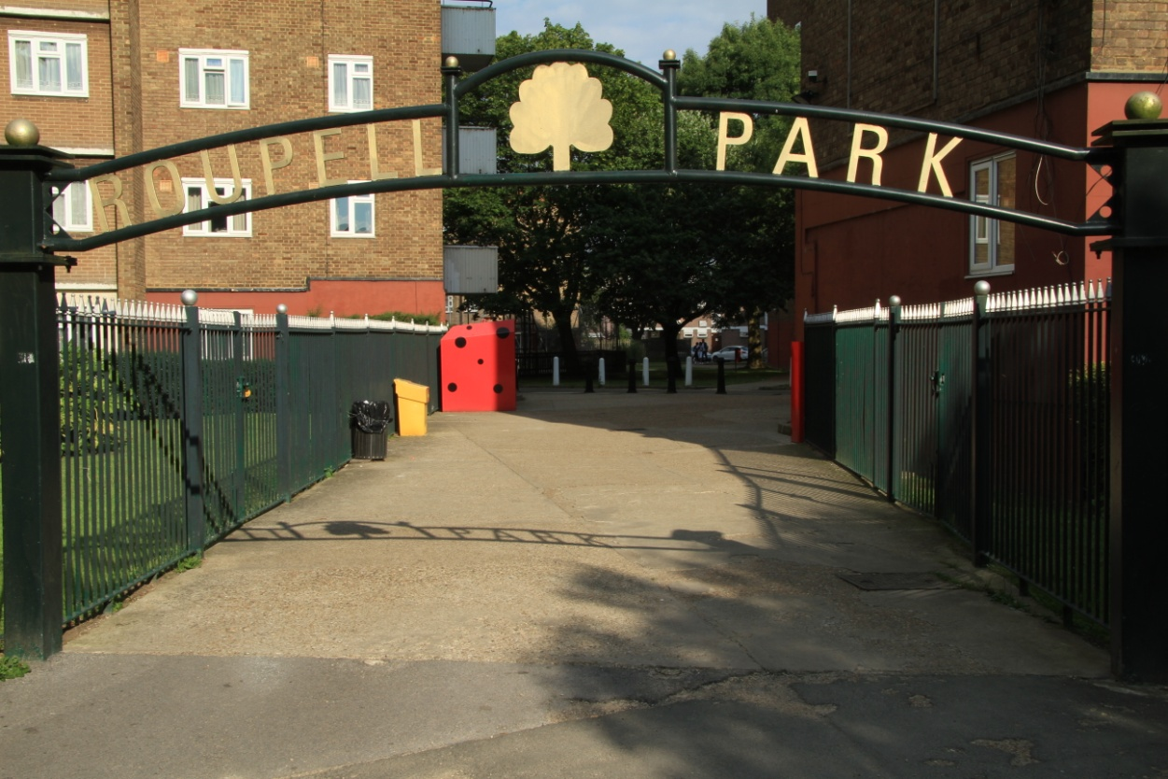

**Appendices**

1. Jargon buster
2. Summary of management agreement - TMO responsibilities
3. SWOT - Strengths, weaknesses, opportunities, threats analysis
4. Action plan

**Appendix A – Jargon Buster**

Some readers may be new to some of the terms or abbreviations used in this document. Below, we have set out a short glossary which explains some of these terms and abbreviations.

|  |  |
| --- | --- |
| **Term** | **Meaning** |
| **AGM** | Annual General Meeting held each year to present the TMO’s annual report, accounts and elect members of the Management Board for the next year. |
| **ALMO** | Arms Length Management Organisation. Lambeth Living is the Council’s ALMO and is responsible for managing the Council’s housing stock and providing council retained services to TMOs in the borough. |
| **KPI’s** | Key Performance Indicators – areas that the TMO’s performance is measured on. |
| **BME** | Black and minority ethnic - this denotes people and communities who are black, Asian or from other ethnic communities |
| **Decent Homes** | A standard set by the Government requiring all social housing to be wind and weather tight, to meet minimum standards for housing set down in law, have reasonably modern kitchens and bathrooms (for tenants) and be in a good state of repair. |
| **Housing Revenue Account (HRA)** | The Council’s ring fenced account which covers income and expenditure on council housing only. |
| **Management Agreement** | A binding legal agreement between the TMO and the landlord organisation (Lambeth Council) setting out the services that the Council has delegated to the TMO. |
| **Management Allowances** | The money that the Council pays the TMO to provide the services delegated to the TMO which are set out in the management agreement. They should represent what it would cost the Council to provide the same services. |
| **National Federation of Tenant Management Organisations (NFTMO)** | An organisation which represents and advises tenant management organisations. |
| **Right to Manage Regulations** | Regulations that were introduced by the then Government in 1994 that give tenants the right to manage housing services provided they follow the process laid down. The Regulations have since been updated in 2008 and most recently in 2012. |
| **SMART** | This is an acronym which refers to goals or objectives set by an organisation which are **S**pecific, **M**easurable, **A**ttainable, **R**ealistic and **T**imely. |
| **SWOT** | An acronym for an exercise which assesses an organisation’s **S**trengths, **W**eaknesses, **O**pportunities and **T**hreats. |
| **Tenant Management Organisation (TMO)** | An organisation set up under the Right to Manage Regulations by local tenants and residents to run an estate/area based housing service. A TMO is set up to run services for the benefit of its membership and is a not for profit organisation. The term TMO includes tenant management co-operatives and estate management boards. |
| **VFM** | Value for Money - a long used term, adopted by the Government to denote a service which has an appropriate balance between cost, services, quality and satisfaction, etc. |

**Appendix B – Summary of the Management Agreement between RPRMC Ltd and Lambeth Council**

**Management Agreement**

**Clauses in the Management – The option denotes level of responsibility with normally Option A representing that function stays with the Council and depending on the function option B (either TMO and council together or TMO function) or option C ( TMO function) or Option D/E (where there is a range of options option D/E denotes maximum responsibility with TMO). Many clauses are standard clauses.**

|  |  |
| --- | --- |
|  | Option in MA |
| **Chapter 1 General Provisions**  **Clause no.** | **RPRMC** |
| 1 Parties to the Agreement – Lambeth Borough Council and RPRMC | Standard |
| 2 The Council and the Property – Links to a schedule which includes a list of properties and a map of the TMO managed area | Standard |
| 3 The Tenant Management Organisation – the type of legal entity that the TMO is – RPRMC is a registered Industrial and Provident Society | Standard |
| 4 Statement of Exercise of Management Functions under the Right To Manage | Standard |
| 5 Starting Date - same starting date for all services | 5A |
| 6 The Tenant Management Organisation’s Exercise of Management Functions | Standard |
| 7 Insurance – List of the TMO and the Council’s insurance responsibilities | Standard |
| 8 Exclusion of Section 27(13) of The Housing Act 1985 and general Indemnity- TMO and Council indemnifies the other party for loss or damage as a result of error or failure on their part | Standard |
| 9 Confidentiality - TMO and council treats all information relating to tenants and leaseholders as strictly confidential and publish Code of Confidentiality | Standard |
| 10 Equal Opportunities TMO will publish as Equalities and diversity policy as a schedule to the management agreement | Standard |
| 11 Training – TMO will ensure its members, board members and staff have the necessary training to meet obligations set out in the management agreement | Standard |
| 12 Information to Tenants–TMO to provide residents with information about the workings of the TMO | Standard |
| 13 Conflicts of Interest – Board members and employees must declare all personal, private and business potential conflicts of interest and these should be entered in a register | Standard |
| 14 Right To Represent – TMO can act on a resident’s behalf if that resident so wishes | Standard |
| 15 Council’s Right of Access to Dwellings – Council has right of access to the property and dwellings | Standard |
| 16 Interpretation of this Agreement and General Provisions - About the numbering of clauses in the agreement | Standard |
| 17 Decision to Continue this Agreement - TMO must hold a vote to continue at each AGM and a secret ballot or anonymous questionnaire every 5 years | Standard |
| 18 Variations to this Agreement – Sets out how the agreement can be varied | Standard |
| 19 Failure To Perform [Link to Chapter 7 and Chapter 8] Sets out the procedure of either party fails to perform and links to a Supervision Procedure set out in the schedules if there are serious failings on the TMO | Standard |
| 20 Ending this Agreement – Sets out how the management agreement can be ended by either the Council or the TMO | Standard |
| **Chapter 2 Repairs and Maintenance** | **RPRMC** |
| 1 Repairs TMO is responsible for responsive repairs as set out in schedule 1 Annex A | 1B |
| 2 Repairs Council is responsible for some repairs as set out in schedule 1 Annex B | 2B |
| 3 Failure to repair – Procedure if either party fails in its repairing duties as set out in the Agreement | Standard |
| 4 Major Works: Initiation by the Council – Council can draw up proposals for major works and must consult the TMO | Standard |
| 5 Requests for Major Works by the Tenant Management Organisation – TMO can request the Council to do major works | Standard |
| 6 Major works –Both the Council and/or the TMO may be responsible for major works | 6D |
| 7 Partnering contracts made by the council with third parties in respect of major works – TMO does not have right to take on major works of part of Council partnering contract | Standard |
| 8 Replacement repairs – Replacement of component parts and improvements is a Council responsibility | Standard |
| 9 Insurance - Council makes insurance claims - TMO carries out repairs of its responsibility | 9B |
| 10 Estate Services - TMO responsible for services set out in schedule 6 | 10B |
| 11 Technical advice – Council must provide technical advice of requested | Standard |
| 12 Right to improve and leaseholder improvements – Liked to improvements policy set out in schedule for receiving and progressing requests for resident to carry put improvements | Standard |
| 13 Right to repair–Linked to schedule for processing right to repair claims | Standard |
| **Chapter 3 Rents** | **RPRMC** |
| 1 Confidentiality and procedures –TMO will treat all information as strictly confidential | Standard |
| 2 Rent collection- TMO administers collection of rent into Council’s bank account | 2B |
| 3 Arrears control –TMO manages all aspects of rent arrears | 3E |
| 4 Starting date arrears –TMO manages all rent arrears stating date of agreement | 4C |
| 5 Former tenant arrears - Council function | 5A |
| 6 HB payments- Not applicable | 6A |
| 7 Setting rent payable by tenants – Councils sets the total rent | Standard |
| 8 Notification of rent - Council function | 8A |
| 9 Payment of rent due - Not applicable | 9A |
| 10 Void allowance - Not applicable | 10A |
| 11 Bad debt - Not applicable | 11A |
| 12 Void/rent waiver - Not applicable | 12A |
| **Chapter 4 Service charges** | **RPRMC** |
| 1 Confidentiality and procedures - TMO will treat all information as strictly confidential | Standard |
| 2 Information - TMO will keep accurate information to enable the Council to collect service charges | Standard |
| 3 Service charge and ground rents billing and collection - Council function | 3A |
| 4 Service charge and ground rent arrears –TMO manages arrears | 4B |
| 5 Consultation under S.20 of Landlord and Tenant Act 1985 Council function | 5A |
| 6 Supplementary provisions in relation to clause 5 Each party will provide information as required for the other party to fulfil its obligations | Standard |
| 7 Other provisions under Landlord and Tenant Act 1985 – Supplying regular statement of accounts to leaseholders - Council function | 7A |
| 8 Payment of service charges to the Council - Council function as Council collects service charges | 8A |
| 9 Financial incentives and penalties for TMO if collecting arrears | Standard |
| **Chapter 5 Financial management** | **RPRMC** |
| 1 Calculation and payment of allowances – Link to schedule setting out calculation | Standard |
| 2 Payment of allowances - Council pays TMO allowance as set out in schedule | 2B |
| 3 Payment of expenses - TMO receives allowances from the counciland pays its own expenses | 3B |
| 4 TMO's banking arrangements - TMO maintains bank accounts as it sees fit | 4B |
| 5 Financial control and accounting standards – Link to financial procedures set out in schedule. TMO must provide Council with budget, quarterly revenue report and annual accounts | Standard |
| 6 Financial year – Runs from April to March | Standard |
| 7 Restriction on investments – TMO must be able to access its funds with maximum 3 months notice | Standard |
| 8 Reserve Funds - TMO must maintain a reserve fund | 8B |
| 9 Major works account Not applicable | 9A |
| 10 Financial report & surplus - TMO provides reports and creates surplus fund | 10B |
| 11 Loans to the TMO – Council can provide the TMO with a loan or must gove written reasons for a refusal | Standard |
| 12 Interest of payments - Either party can charge interest on late payments | 12B |
| 13 Set off payments- Either party can deduct money owed from payments due | 13B |
| **Chapter 6 Tenancy management** | **RPRMC** |
| 1 Information to applicants and new tenants – Council must provide information about the TMO Link to procedure for TMO introductory meetings with new tenants | Standard |
| 2 Consultation between TMO and Council – Council must consult TMO before altering its allocation scheme and must consider TMO’s proposals | Standard |
| 3 Selection of tenants –Local lettings policy for transfers (downsizing tenants), Council selects tenants for all other allocations | 3D |
| 4 Transfers - TMO administers transfer applications | 4B |
| 5 Intro tenants –TMO monitors Introductory Tenancies | 5C |
| 6 Variations to tenancy - Council makes variations to the tenancy agreement | 6A |
| 7 Breach of tenancy - TMO is authorised to end tenancies | 7C |
| 8 Ending and renewing flexible tenancies - The Council makes decisions following discussion with the Tenant Management Organisation | 8B |
| 9 Anti social behaviour - TMO is authorised to deal with anti-social behaviour and harassment | 8B |
| 10 Residents disputes - TMO is authorised to deal with disputes | 9B |
| 11 Unlawful occupation - TMO takes action to terminate unlawful occupation | 10C |
| 12 Void dwellings - TMO manages void dwellings | 11B |
| 13 Right to exchange - TMO administers the Right to Exchange | 13B |
| 14 Right to assign - Council administers the assignment | 14B |
| 15 Applications to sublet - Council administers applications from tenants to sublet | 15B |
| 16 Right of succession - Council administers the Right of Succession | 16B |
| 17 Giving consents – TMO and council have responsibility for giving consents to residents as set out in schedule | Standard |
| 18 Right to buy –TMO manages rent arrears Council consults TMO on RTB applications | 18B |
| 19 Enquiries before exchange of contracts - TMO responds to enquiries | 19B |
| 20 Use of the property TMO must get council’s written consent for modernises, improves any structure or builds any new structure. | Standard |
| **Chapter 7 Staffing and relationship Council** | **RPRMC** |
| 1 Transferring staff and protecting employment under TUPE regulations – not applicable - | Standard |
| 2 Employment of staff- TMO employs ots own staff and recruitment policy and terms and conditions of employment are included in schedules | Standard |
| 3 Secondment of staff - not applicable | 3A |
| 4 Employment of contractors- TMO maintains its own approved contractor list | 4B |
| 5 Access to Council officers - Council must make sure TMO has access to council officers | Standard |
| 6 Liaison officers – Council nominates council officer to be liaison officer between council and TMO | Standard |
| 7 TMO Liaison committee – Council to set up a TMO Liaison committee where more than one TMO in the borough | Standard |
| 8 Council's nominee - Council does not have nomination rights to the board | 8A |
| 9 Help to the TMO – Council must consider all requests for help form the TMO | Standard |
| 10 Service of notices – How and on who in the TMO or Council formal notices should be served | Standard |
| 11 Misdirected notices – How to deal with misdirected notices | Standard |
| 12 Notice of legal proceedings – Each party must inform the other of any legal proceedings | Standard |
| 13 Information to be provided - Each party must provide the other party with information it needs to comply with the Agreement | Standard |
| 14 Changes in management or ownership – Council must inform the TMO of any proposed changes at the earliest possible stage | Standard |
| 15 Statutory consultation- Council complies with statutory consultation requirements | 15A |
| 16 Non-statutory consultation – Either party can carry out consultation as it thinks desirable but should inform the other party | Standard |
| 17 Complaints about the Tenant Management Organisation’s or council’s performance as manager of the property dwellings | Standard |
| 18 Disputes and arbitration Link to procedures set out in schedules | Standard |
| 19 Information to the Secretary of State - Either party must provide information to Secretary of State as requested | Standard |
| **Chapter 8 Performance, monitoring, reviewing** | **RPRMC** |
| 1 The Tenant Management Organisation’s performance standards - Set out in schedule | Standard |
| 2 The Council’s performance standards - Set out in schedule | Standard |
| 3 Regular monitoring and development meetings Council and TMO should hold periodic monitoring meetings | Standard |
| 4 Annual review – TMO reviews its performance and send report to council and residents | Standard |
| 5 Equalities and diversity Council reviews effectiveness of TMO’s Equalities procedures | Standard |
| 6 Periodic and special reviews – Council may carry out a review of TMO’s performance not more frequently than once every 3 years | Standard |
| **Chapter 9 Definition of terms used in the Agreement** | **RPRMC** |

**Appendix C – Strengths Weakness Opportunities Threats Exercise**

|  |  |
| --- | --- |
| **STRENGTHS** | **WEAKNESSES** |
| * Sound, financial position * Policies and procedures * Active board * Training and development * Good officer leadership * Recognising weaknesses * Open to change * Secure funding * Community support * Good survey results/continuation ballot * Good housing management performance * Improving relationship with Council * Improved board communication * Good and committed staff * Direct labour organisation * Knowledge of community * Local office * Staff are accountable * Responsive services * Repairs (minor)completed quickly * Low staff turnover * Clean estate free of graffiti | * Gaps in staffing capabilities * Policies and procedures * Some services outside TMO control i.e. heating, hot water, lifts, roofs * No access to capital funding * TMO cannot shape or control capital spend * Rubbish dumping * Not enough parking * Lack of awareness of TMO in community and locally * Community involvement * Consultation and communication with community * Lack of involvement from local councillors * Not enough ‘added value’ i.e. people’s welfare and well being * Low staff turnover * Struggle to recruit quality people * Lack of flexibility/control over investment * Lack of investment is a risk * Difficult to minimise risk * Inadequate contract management |
| **OPPORTUNITIES** | **THREATS** |
| * Employ staff with the right skill set * Training and development for staff and the board and residents * Resident workshops on various topics * New management agreement opportunities * Self financing for TMOs * Building community support * Providing support to tenants e.g. with their finances * Developing relationship with local businesses * Developing relationship with local councillors * Councils co-ordination strategy – services * Contractors – using local labour * Using local contractors * Apprenticeships for DLO | * Lack of participation * Board sustainability * TMO not managing risk i.e.. finance, legislation changes * Lack of capital investment in estate * Further welfare changes impacting upon community * Failing the 5 year ballot * Lambeth taking services back/ending management agreement * Cost/inflation pressures on repairs and maintenance spend * Increased leaseholder turnover * Increase in Buy to Let sales on estate * Security – feeling safe on estate * Political threat to social housing |

**11. Appendix D –Action plan**

**Our Three year plan**

Having completed a recent SWOT exercise, exploring our strengths and weaknesses plus the opportunities and threats facing our TMO; our risk assessment and taking into account our vision and values and the services we are providing -we have developed a SMART three year plan, to make sure we achieve everything we have set out to do.

We have identified lead board members and/or staff who have responsibility for overseeing the delivery of specific actions and will report on progress to the board. This action plan will be monitored by the Board quarterly.



Indicates Year 1 activities

|  |  |  |  |
| --- | --- | --- | --- |
| **Strategic objective 1**  **Delivering high quality homes and services** | | | |
| **Actions:**  **Create a clean, safe and welcoming environment with excellent facilities** | **Measured by** | **Lead person responsible** | **When** |
| Investigate the use of CCTV on estate hotspots to minimise crime, vandalism and deter unwanted activity | Reduction in crime and vandalism when CCTV deployed | Estate Director | Year 2 |
| Work closely with Lambeth Living to ensure effective delivery of Decent homes improvements and the capital programme | Project liaison meetings. No. of complaints/ complaints resolved. Issues arising from works addressed within agreed timescales. | Estate Director | Year 1/2 |
| Investigate plans for enhancing estate shared spaces | Improvements agreed and funded. Improved resident satisfaction | Estate Director/sub committee | Year 2 |
| Develop surplus spend plan in consultation with residents | Surplus spend plan in place and delivered. | Estate Director/ Treasurer | Year 1 |
| Continue with programme of bringing unused garages back into service | No. of garages let | Estate Director | Year 1  ongoing |
| Ensure communal TV system is fit for purpose | Residents are able to receive a wider range of digital functions through the communal aerial system | Estate Director | Year 2 |
| **Actions:**  **Delivering excellent services that respond to the changing needs of residents** | **Measured by** | **Lead person responsible** | **When** |
| Develop and publicise Customer Care charter including service pledges to residents, training for staff | Charter in place, staff training taken place, increase in residents’ satisfaction across all TMO services | Estate Director | Year 2 |
| Set up residents mystery shopping with training for residents and reporting – consider incentives for residents taking part | Mystery shopping scheme in place. Quarterly reports to board with improvement plan where necessary | Estate Director | Year 2 |
| Review IT provision and look at some stand alone systems supporting Lambeth system *(finance, repairs, email) to ensure more effective working | Review completed, systems in place where changes required. | Estate Director | Year 2 |
| Develop improvement plan with targets for estate cleaning and caretaking and research potential for weekend cleaning | Improvement plan in place. Improved customer satisfaction on survey | Estate Director | Year 1 |
| Review gardening provision on estate | Review completed. Report to board. | Estate Director | Year 1 |
| Annual/bi annual satisfaction survey with feedback newsletter | Survey completed and newsletter to residents. | Estate Director | Year 2 annually |
| Improvement plan developed to address any areas where not meeting agreed standards | Improvement plan in place to address shortfalls | Estate Director | Year 1 |
| **Actions:**  **Creating a safe, green environment and reducing our carbon footprint** | **Measured by** | **Lead person responsible** | **When** |
| Promote and facilitate increased levels of recycling | Levels of recycling, reduction in rubbish, increased resident satisfaction | Estate Director | Year 2 |
| Increase biodiversity and wildlife through green space improvements | Wildlife areas created | Estate Director | Year 2 |
| Engage community especially young people in green projects | Projects and no. of people (age) participating | Chair | Year 2 |
| Look at potential for community growing space and/or allotments | Report to board identifying potential areas. | Estate Director/CDO | Year 2 |
| Develop office environmental policy to minimise waste and maximise recycling | Policy in place. Reduction in waste and energy usage | Estate Director | Year 2 |

|  |  |  |  |
| --- | --- | --- | --- |
| **Strategic objective 2**  **Making our business stronger for the future** | | | |
| **Actions:**  **To make sure that our governance and staffing structure enables the successful operation of RPRMC** | **Measured by** | **Lead person responsible** | **When** |
| Develop a Board sustainability policy supported by an induction policy and user friendly pack to encourage interest in board membership | Policy and induction pack in place. No of residents expressing an interest – reported to board | Secretary | Year 1  Ongoing |
| Review and update the registered TMO rules to ensure they conform to current best practice and are fit for purpose | New model TMO rules (amended as required) adopted | Secretary | Year 2 |
| Review TMO policies and procedures, identify gaps and draft new policies where needed | Policy and procedure manual in place | Chair/Estate Director | Year 1  ongoing |
| Work to ensure Board and membership is representative of the community - direct contact /targeted activity at underrepresented group/s | Board demographic/tenure monitoring/report to board with recommended actions. Reflected in Consultation and Involvement strategy. | Secretary/ Estate Director | Year 2 |
| Carry out evaluation of Board’s activities/performance/ decisions annually | Evaluation taken place – report on action points | Chair | Year 1 |
| Develop Learning plan for Board members – training open to all TMO members | Learning plan in place and feedback to board on activities | Chair | Year 1 |
| Increase membership of the TMO target 80% of eligible households by year 3 through a membership drive (introductory meeting with new tenants, membership pack, door knocking campaign, events) | All new tenants signed up as members. 80% membership by year 3 | Secretary | Year 3 |
| Review staffing structure to identify any skills gaps and to ensure it is fit for purpose | Review completed – report to board and action plan | Estate Director | Year 2 |
| Make sure up to date staff policies in place including staff appraisals, pension provision.  Training and development plan in place for all staff | Appraisals taken plan and development plans in place. Pension provided for all staff | Estate Director | Year 1 |
| **Actions:**  **Ensure TMO remains on sound financial footing through effective financial management** | **Measured by** | **Lead person responsible** | **When** |
| Ensure financial systems and procedures are fit for purpose including finance IT system and regular financial reporting | Effective, real time management of finances. Board evaluation of financial reporting. Updated procedures. | Treasurer/ Finance Manager | Year 1 |
| Increase amount in designated Contingency Reserve Fund (minimum 10% of annual allowances) through transfer from surplus and a proportion of savings year on year | £25,000 transferred annually. £75,000 by year 3. Surplus fund stands at £237k | Treasurer Finance Manager | Year 1  annually |
| Consider ways of generating additional income in the future such as providing services to leaseholders and providing services to other TMOs/nearby Lambeth managed blocks, local housing providers | Leaseholder plan in place and income generated.  Service level agreements/contracts in place and income generated. | Treasurer/ Estate Director | Year 3 |
| Develop surplus spend plan (for Year 2 onwards) in consultation with TMO members and include in business plan | Surplus spend plan in place. Delivery report to members and residents. | Treasurer/ Estate Director | Year 2 |
| Explore options for future investment of Roupell Park including self financing and stock transfer options | Exploring the Options study. Report to board. | Chair/ Estate Director | Year 3 |

|  |  |  |  |
| --- | --- | --- | --- |
| **Strategic objective 3**  **Building a strong and cohesive community** | | | |
| **Actions:**  **An active and engaged community through improved communication and participation** | **Measured by** | **Lead person responsible** | **When** |
| Community development programme including outreach work prepared and delivered by newly created post Community Development Officer in consultation with residents | CDO and programme in place. Reports to board on progress: activities, increased participation, satisfaction levels. | Chair/Estate Director | Year 1 |
| Develop website and consider using social media to communicate key ideas, gather views. Set up email communication list. Community blog. Set up a facility for repairs and other matters to be reported online | Website operational, no of hits, blog activity, reports online, social media activity | Estate Director/Community Development officer/sub group | Year 1 |
| Regular newsletters distributed by email and by hand and on the website | Newsletters circulated/content evaluated | Community Development officer/sub group | Year 1 |
| Sponsor a Youth Forum linking into Lambeth Youth Parliament and to the board – Outreach work with young people | Youth Forum set up/ attendance at some board meetings/activity reports/increased youth engagement | CDO | Year 2 |
| Carry out community mapping exercise obtaining latest demographic info from Lambeth Living | Demographic data obtained, data base created and compared with participation/ service delivery data. Report to board | Estate Director | Year 1 annually updated |
| Review Community Development and Involvement Strategy and action plan including targeted activity to engage with underrepresented groups | Strategy reviewed and action plan of activities in place. Participation monitored | CDO/sub group | Year 2 |
| To work with Board members and the wider community to identify vulnerable and elderly house bound residents and ensure regular checks and contact | Register completed. Contact taking place | Estate Director | Year 2 |
| Consult on a programme of resident workshops on topics residents will find valuable examples could include managing debt, basic DIY skills, preparing a CV, job interview skills, basics of cooking, | Workshop programme in place. Participation/satisfaction monitored | CDO | Year 2 |
| Suggestion box – online, in newsletters/ and in the office | Reports to board on ideas, suggestions, feedback in newsletters/website on proposals initiated | CDO | Year 1 |

1. Source for data: Lambeth Living housing database, Lambeth Council Equalities Insight Summary July 2013
2. References to tenants relate to secure and introductory tenants only. No data is available for leaseholders.
3. See Appendix D Action Plan